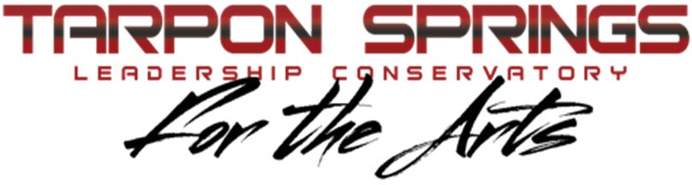
26th Annual Tarpon Springs
Outdoor Music Festival
Saturday, October 29, 2022
Sponsorship Guide
Tarpon Springs Band Boosters, Inc.
Post Office Box 642 Tarpon Springs, FL 34688
A 501(c)(3) Tax - Exempt Organization
Tax ID#: 59-2135073

DIRECTORS- EVENT NAME SPONSOR (1) - $7,500
- Sponsor Name tagged to event and promoted throughout event.
- Sponsor name on front of estimated 500 festival shirts
- Recognition and participation in on-field award ceremony
- Cover page program ad (color)
- Sponsor provided banner displayed in prominent location.
- 10 x 10 sponsor expo booth
- 15 sponsor passes, premier VIP named seating

JAZZ ENSEMBLE - FIELD SPONSOR (5) - $3,500
- Sponsor provided banner displayed in prominent location
- Recognition and participation in on-field award ceremony
- Full page program ad
- 10 x 10 sponsor expo booth
- 8 sponsor passes, VIP named seating

ORCHESTRA – PROGRAM SPONSOR (2) OR AWARDS
DIVISION SPONSOR (5) - $1,500
- Sponsor has choice of
  - one of two center full-page ads in program or
  - name on each trophy awarded in each division
- Recognition and participation in on-field award ceremony
- Sponsor provided banner displayed in prominent location.
- 10 x 10 sponsor expo booth
- 4 sponsor passes, VIP named seating

DRUM MAJOR- FESTIVAL SHIRT SPONSOR (2) - $5,000
- Sponsor name on sleeve of the estimated 500 festival shirts
- Recognition and participation in on-field award ceremony
- Back outside cover program ad (color)
- Sponsor provided banner displayed in prominent location.
- 10 x 10 sponsor expo booth
- 10 sponsor passes, VIP named seating

COLOR GUARD – EVENT WRISTBAND SPONSOR (3) - $2,500
- Sponsor name or logo on each of the estimated 2,000+ admission wristbands
- Recognition and participation in on-field award ceremony
- Full page program ad
- Sponsor provided banner displayed in prominent location.
- 10 x 10 sponsor expo booth
- 6 sponsor passes, VIP named seating

PERCUSSION – EXHIBITING SPONSOR (20) OR AREA
SPONSOR (13)- $600
- Area Sponsors: Sponsor name displayed on sign at sponsored location. Choose from Water Station Sponsor (4), Directors’ Lounge Sponsor, Courtesy Shuttle Sponsor (4), Band Warm Up Area Sponsor, Color Guard Warm Up Area Sponsor, Percussion Warm Up Area, or Welcome Registration Center Sponsor.
- Exhibiting Sponsors: Receive a 10 x 10 sponsor expo booth to market business to all Festival guests.
- Half page program ad
- 2 sponsor passes, VIP named seating
- Sponsor provided banner displayed in prominent location.

Sponsor Name: Sponsorship Level and Amount: Sponsor Address: City State ZIP Sponsor Contact Person: Tel: E-Mail:
For additional information visit https://bit.ly/3QenU8W

**Conservatory Student Responsible for Sponsorship:
Email questions or program ad (7” W x 10” H) in pdf, jpeg, or png format to sponsorships@tarponspringsband.com by 9/30/22. Please make checks payable to: Tarpon Springs Band Boosters, Inc. Attn: Outdoor Music Festival.
Thank you for your support!
The Tarpon Springs Leadership Conservatory for the Arts is a nationally recognized program providing an innovative, seamless curriculum in academic study, instrumental music, dance, and leadership skills designed to develop tomorrow’s leaders.

